Learning Styles Handout: (a.k.a.: Sensory Preferences)
Scientists have for years tried to understand the best ways students learn through research. One of the popular theories, to this day, is the VARK model. Although educators and researchers disagree on how many learning styles may exist, there are at least four that many accept as general classifications:

• VISUAL: Learns well when aided by images, pictures and spatial organization of elements

• AUDITORY: Learns well when aided by music, sound, rhyme, rhythm, speaking or listening

• READING/WRITING: Learns well by reading or writing the material

• KINESTHETIC: Learns well when moving and/or using hands and sense of touch. (Writing or drawing diagrams are physical activities that can fall into this category as well.)

Learning styles can be explained and better understood by considering the key role played by cognitive strengths and weaknesses. Cognitive skills are the core skills the brain uses to think and learn and explain why some students struggle to learn in various settings. Cognitive strengths and weaknesses can even explain learning style preferences.

Every student has a strategy they use to remember information more efficiently while studying. Some of them take notes; some make diagrams; some prefer to listen to lectures, etc. Since no learning style fits all students, scientists have conducted research to understand the way students learn new information best.

Tips for All Learners
Your learning style is based on these four basic categories that overlap in various ways. You will discover that you have traits in all categories, but as you consider this information, you will learn the dominant traits that characterize your primary learning style.

Most people use a combination of learning styles but have a clear preference for just one. Understanding your learning style can make it easier for you to communicate and reduce frustration when learning something new.

Once you know your primary learning style, it’s a good idea to try to attain knowledge in the form that works best for you. Although it’s tempting to stick with what works, keep in mind that a preferred learning styles might change as a person grows. Plus, people who can learn in a variety of ways can more readily absorb information. Challenging oneself to learn in a variety of ways can help to develop different kinds of skills and improve learning overall.

Understanding Learning Styles in the Classroom
Learning is not one size fits all. In a typical classroom, some kids process information best by hearing the teacher explain it, some learn by seeing what’s on the chalkboard, and others learn through hands-on exercises. That’s why understanding learning styles is an important part of supporting students in school.

Understanding Learning Styles: Visual Learners
Visual learners are individuals who prefer to take in their information visually—be that with maps, graphs, diagrams, charts, and others. Visual learners process new information by reading, looking at graphics, or watching a demonstration. Individuals with this learning style benefit from seeing information on a chalkboard or in an illustration, but they may grow impatient listening for long periods of time, and they don’t necessarily respond well to photos or videos, rather needing their information using different visual aids such as patterns and shapes. The best way to present to visual learners is by showing them the relationship between different ideas visually.

Strategies for visual learners include:
• Using flash cards
• Studying charts, tables, and maps
• Drawing illustrations
• Writing things down and reviewing notes
• Highlighting and underlining
• Color-coding information

Understanding Learning Styles: Auditory Learners
Auditory learners are individuals who learn better when they take in information in auditory form when it is heard or spoken. Auditory learners prefer listening to explanations over reading them and may like to study by reciting information aloud. This type of learner may want to have background music while studying, or they may be distracted by noises and need a quiet space to study. They are prone to sorting their ideas after speaking, rather than thinking ideas through before. Since, to them, saying things out loud helps them understand the concept. Auditory learners learn best when information is presented to them via strategies that involve talking, such as lectures and group discussions. They aren’t afraid to speak up in class and are great at verbally explaining things. Additionally, they may be slower at reading and may often repeat things a teacher tells them. They can benefit from repeating back the lessons, having recordings of the lectures, group activities which require classmates explaining ideas, etc.

Strategies that work well for auditory learners include:
• Talking to themselves or with others about what they’re learning
• Reciting important information aloud, perhaps recording it and playing it back
• Reading a book and listening to the audio book at the same time
• Using word associations
• Setting information to a tune and singing it to help remember it
• Limiting distracting noises

Understanding Learning Styles: Reading/Writing Learners
Reading/writing learners consume information best when it’s in words, whether that’s by writing it down or reading it. To them, text is more powerful than any kind of visual or auditory representation of an idea. These individuals usually perform very well on written assignments. There are different ways to get a reading/writing learner to engage and understand a certain lesson. This is probably the easiest to cater to since much of the traditional educational system tends to center on writing essays, doing research and reading books. Be mindful about allowing plenty of time for these students to absorb information through the written word and give them opportunities to get their ideas out on paper as well.

Strategies for reading/writing learners include:
• Describe charts and diagrams by written statements
• Take written quizzes on topics
• Written assignments
• Drawn to expression through writing, reading articles or books
• Write in diaries
• Looking up words in the dictionary and
• Searching the internet for just about everything

Understanding Learning Styles: Kinesthetic Learners
Kinesthetic learners learn by doing and touching. They enjoy a hands-on experience. They are usually more in touch with reality and more connected to it, which is why they require using tactile experience to understand something better. The best way to present new information to a kinesthetic learner is through personal experience, practice, examples, or simulations. They may have trouble sitting still while studying, and they are better able to understand information if they are active while studying.

Strategies for kinesthetic learners include:
• Reading aloud and tracking words on a page with a finger
• Writing things down multiple times to commit them to memory
• Highlighting and underlining
• Playing with a stress ball or toy while studying
• Moving around or taking frequent breaks
• Doing hands-on activities, such as building models or playing games
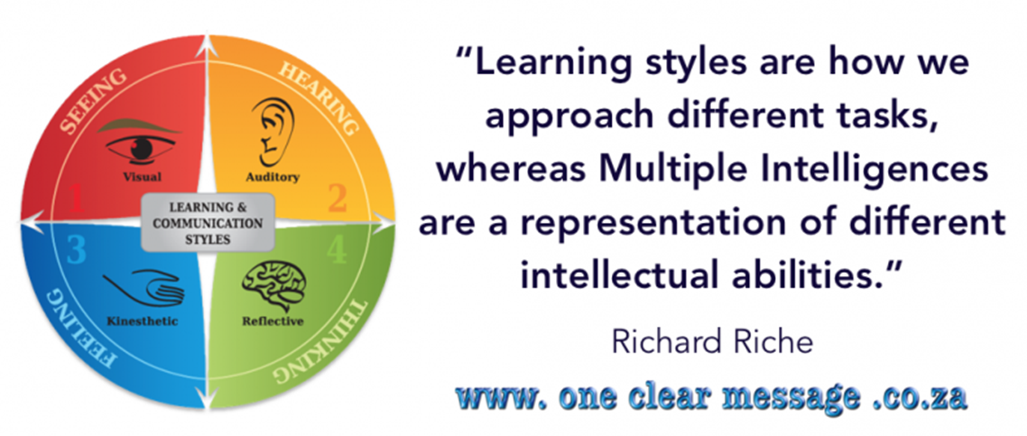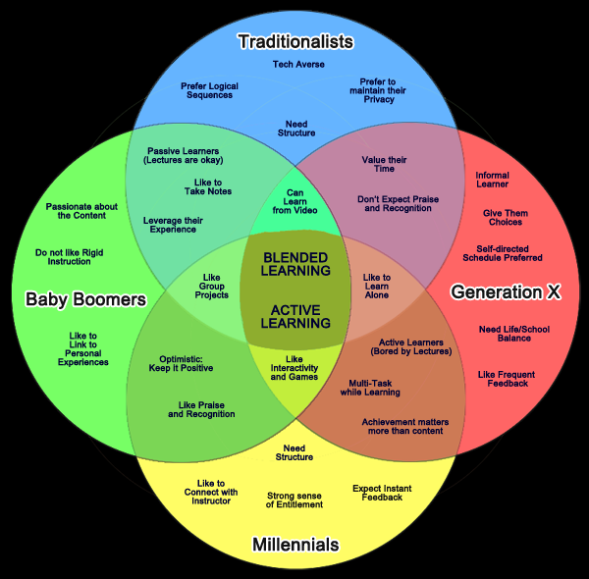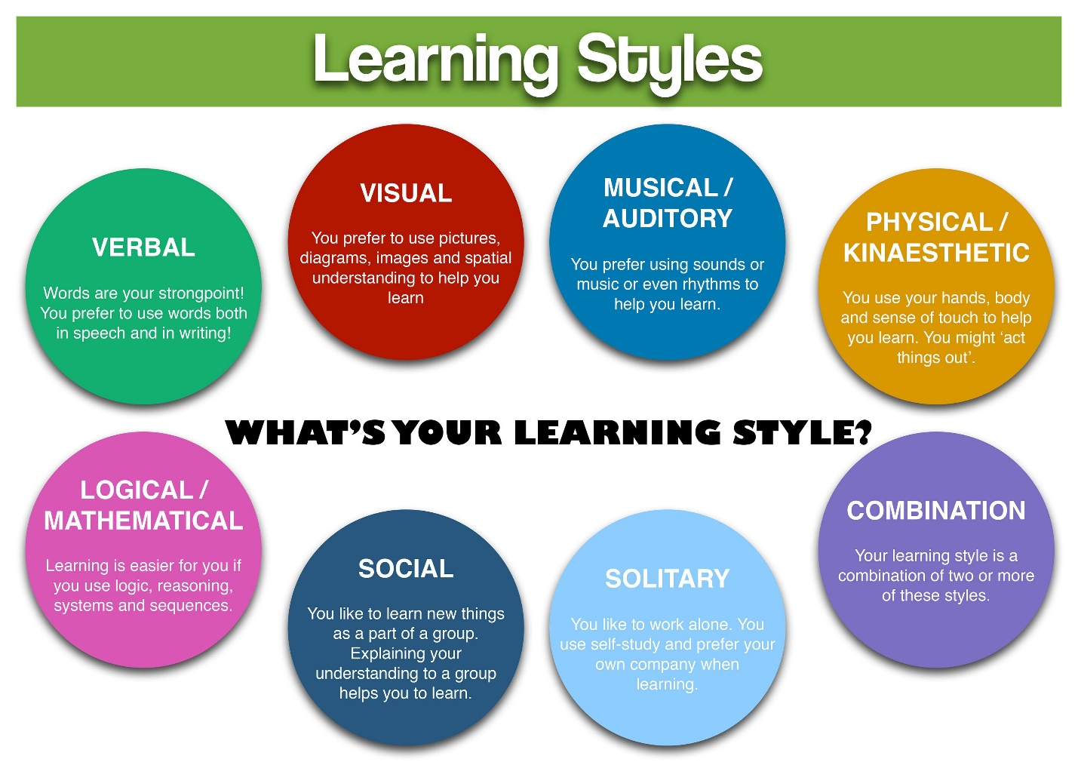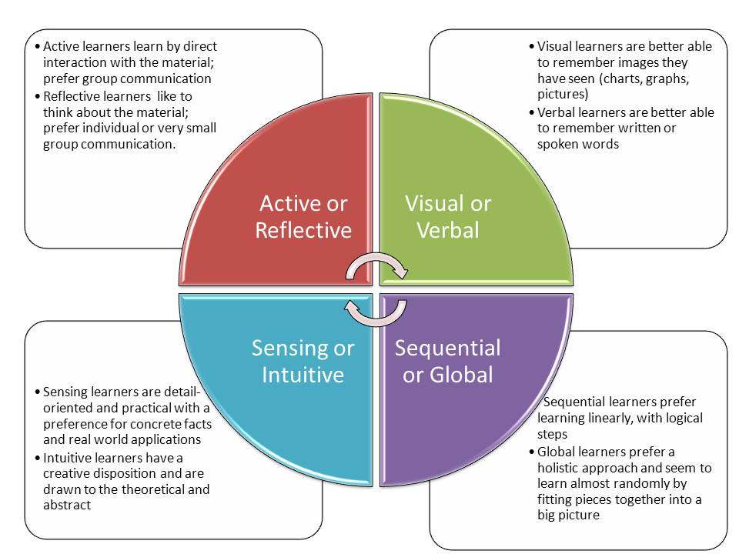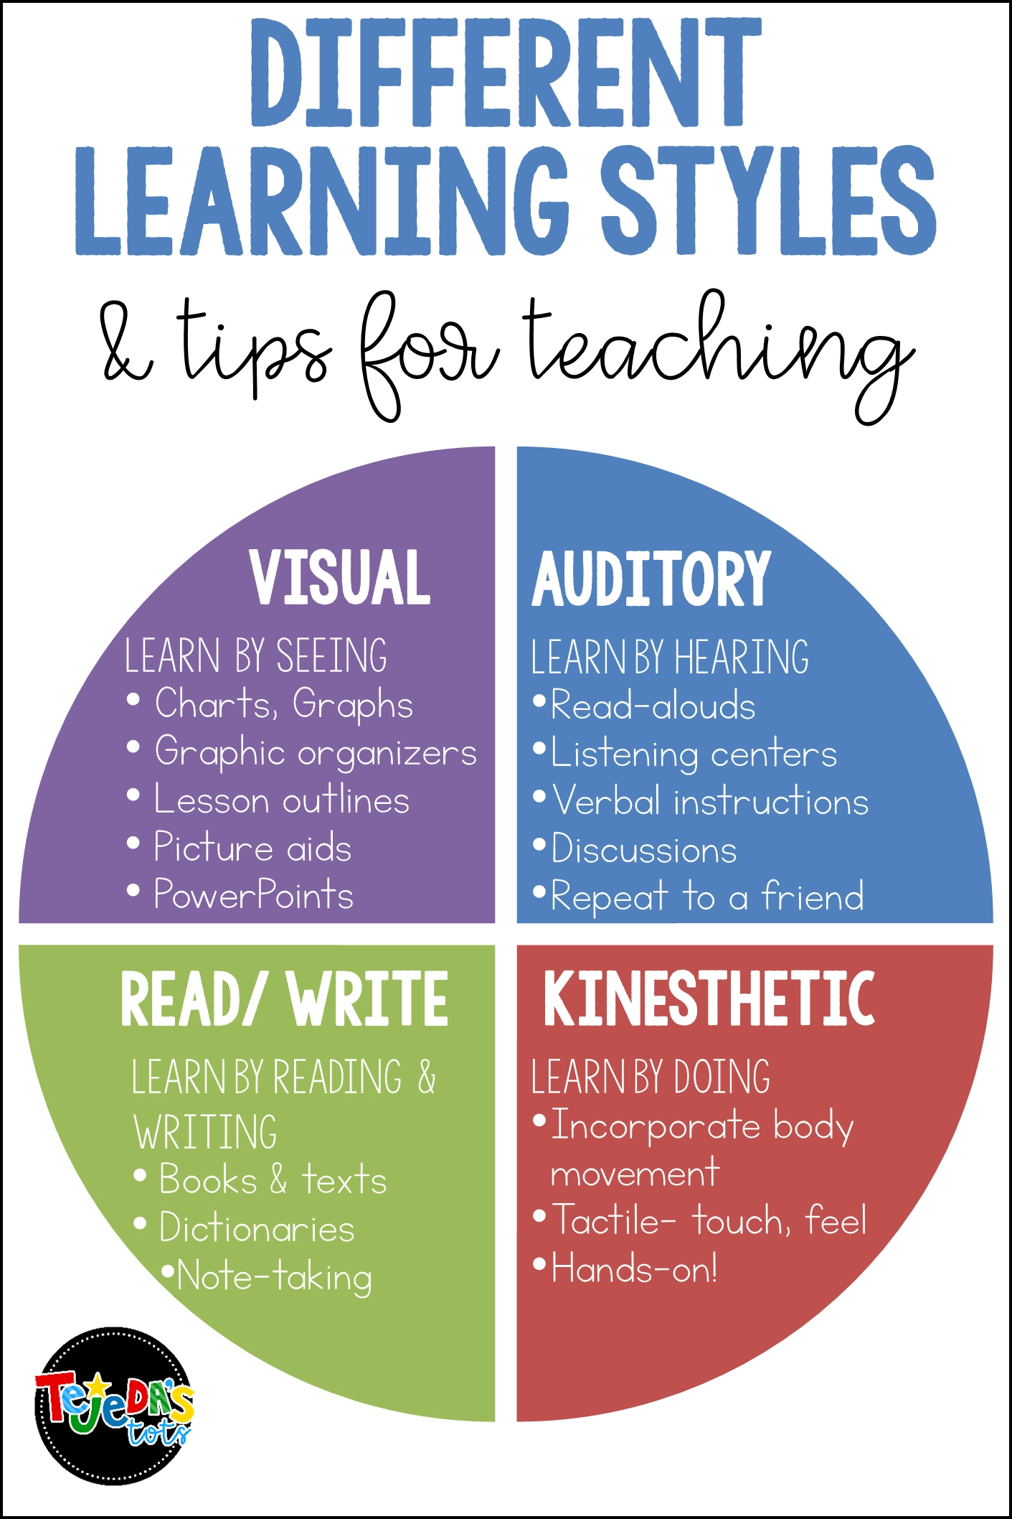
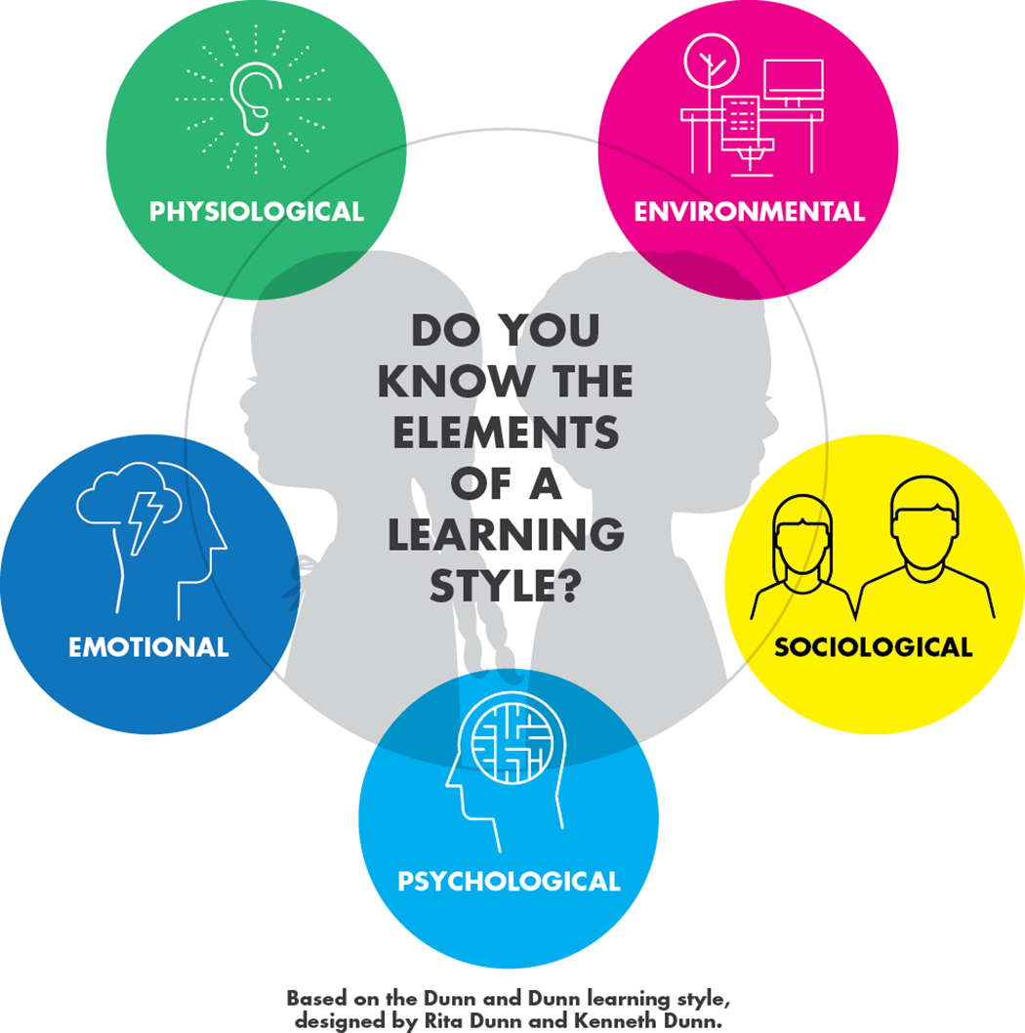
Dunn and Dunn Model
This model was created out of a desire to empower and educate teachers and parents to analyze and motivate their children and students, to optimize their education to their unique learning preferences. The creators recognized that children learn differently, and some children need to be taught differently. This model doesn’t prescribe a fixed style for each learner, but rather lays out a comprehensive set of elements that can influence a learner.
There are five elements to the Dunn and Dunn Learning Styles model:
- Environmental
- Emotional
- Sociological
- Physiological
- Psychological
Each element has specific factors that accompany the element, which a parent or educator can use to gain a deeper understanding of the young minds they are nurturing and guiding and optimize the learning environment for those individual learners.
Environmental Elements
The first category in the Dunn and Dunn learning styles model is Environmental Elements. This refers to where students like to learn, and the physical environment that is most conducive to learning.
Specific Environmental Elements Include:
- Sound
If a child needs quiet, ensure that there is some quiet space at home or in the classroom, or try out headphones to minimize noise. If a child welcomes sound, try playing ambient or classical music when learning.
- Light
If a child likes bright lights, try removing window treatments, or using full-spectrum bulbs. If a child thrives with lower lights, consider installing dimmer switches or lower wattage bulbs in learning areas.
- Seating
If a child likes to learn in an informal environment, let them study where they are comfortable. If a child prefers a formal environment, keep studying focused at a desk or table.
- Temperature
The temperature may affect a child’s ability to concentrate on the subject at hand. Whether they think better in cooler or warmer environments, help make the space conducive to what is most comfortable for learning.
Emotional Elements
Learning can be emotional, and emotions affect how students learn. Emotional elements of a learning style include support, motivation, and/or structure. These play a part in the complex and highly personal identity of a learning style.
Specific emotional elements include:
- Motivation
Some students are driven internally by a desire to succeed academically. Others are not. Pairing students from both groups together may be a good way to encourage peer-to-peer learning and teaching.
- Responsibility
Willingness to cooperate in completing a task is often linked to a student’s understanding of its importance and whether it is done “to” them or “with” them. Empowerment, choice, and control insures their cooperation and compliance. Explain to them why the task you are requesting is relevant and essential. Connecting the task to their personal interests may reinstate their feelings of autonomy and willingness to participate.
- Task Persistence
Try breaking down tasks into smaller short-term assignments or encourage working with other children who have more task persistence. Using praise during the process of working on a task, as well as when it is completed may be good motivation.
- Structure
Structure refers to a child’s preference for specific instruction. If a child is uninterested in instructions before diving into a task — he or she may flourish when you provide objectives, timelines, and creative opportunities instead of specific directions. If a child needs specific instructions, ensure they understand the task, expectations, and resources available.
Sociological Elements
How we interact with others plays a role in our learning styles. Working independently or working in a team, whether under supervision of an instructor or without it, may play a role in how we learn. Learning styles may also vary depending on the specific subjects being learned.
- Independence
Working alone or in a group may say more about a child than just how social they are. Some children learn by bouncing ideas off others. Others prefer to work alone, or independently but close to other peers.
- Authority
Some children feel more comfortable when an authority figure, teacher or parent is present in their learning. Other children prefer independence and autonomy.
Physiological Elements
Learning happens with the body — so how the body can be best utilized to be a conductor of learning, is what the physiological elements address.
- Mobility
Some students need to move to learn. Some children need more frequent breaks or learn better when they have the freedom to move around. Some children can sit still and be engaged, especially when they are interested in a task.
- Intake
Some children concentrate better when fidgeting or chewing. Consider allowing healthy snacks or an approved fidget gadget at a child’s workspace.
- Time of day
Some children may learn best at a certain time of day. Experiment with introducing new material at different times of the day and see how the child does with retaining the new knowledge.
Psychological Elements
Each learner will process information differently.
- Analytical
Some students can grasp concepts more effectively when they are presented in a pattern of steps that lead up to a larger concept. Some students learn more easily when the educator leads with the higher concept first and follows up with the details.
- Impulse and Reflection
When assigned a task, a child that favors an impulsive learning style will dive right into the task and learn while doing. A child that favors a reflective learning style will take time and create a mental model before diving in.

