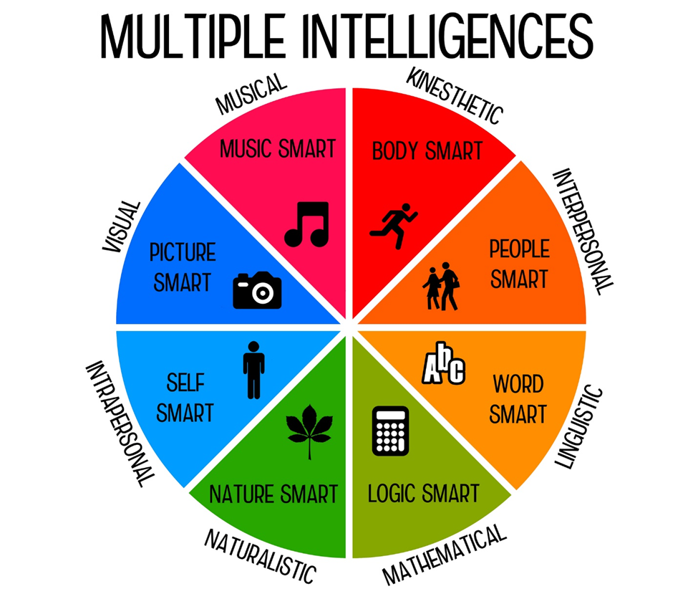

Howard Gardner, a prominent psychologist from Harvard, defined eight "intelligences" in 1983, claiming that all humans have various strengths which define the way they think, learn, and interact in the world. Gardner believes that education can be improved by knowledge and application of these intelligences which address the individual nature of each student. His theory was based on brain research with hundreds of children and adults from various populations including autistic children, child prodigies, children with learning disabilities and adults who had suffered strokes.
Most people who take a multiple intelligence test will have one or two very strong intelligences and one, or even two weaker intelligences, while everything else falls somewhere in the middle. It is unusual to have someone strong in every intelligence, or weak in all eight intelligences. Consequently, keep in mind that the best learning strategies and methods will vary depending on the areas in which a child has the most strengths:
- Verbal-Linguistic - If your score for verbal-linguistic intelligence is high, you probably like writing, telling, or reading stories, poetry, songs, or essays. Effective study strategies using your language intelligence include reading, oral reading or acting, making notes, copying chunks of text, mnemonics, and making a note of ideas or reflections on what you have read.
- Mathematical-Logical - A high score in this category generally indicates that you have a strong aptitude for numbers, logic, and reasoning. You tend to think like a scientist, and numbers seem easy and sensible to you. Study strategies include organizing notes in an outline, categorizing information, and using mnemonic devices.
- Musical-Rhythmic - Musical-rhythmic intelligence applies to those who learn best through song, rhyme, rhythm and sound. Effective study techniques will incorporate these preferences into your lessons. You could try using a familiar tune to remember spelling, processes, formulae, or historical events by making up lyrics.
- Visual-Spatial - If you scored highly in this category, you probably remember best in pictures or images. Making charts, graphic organizers, posters, slideshows, videos, or photo collages work for you as a learning strategy.
- Bodily-Kinesthetic - Those with high bodily-kinesthetic intelligence like to move and have a lot of energy. If your score for this intelligence category is high, you probably enjoy being on the go as much as possible. Since you would rather learn by doing, the most effective study strategies are those which incorporate body movement or hands-on activities into a project.
- Interpersonal - Those with very high interpersonal intelligence interact well with others. They tend to have good social skills and are good at both verbal and nonverbal communication. Effective techniques for enhancing your education using your social intelligence skills include taking part in group or team projects, discussions, book clubs, literature groups, or study groups.
- Intrapersonal - Intrapersonal intelligence is demonstrated by individuals who are self-aware and comfortable spending time alone. Effective study techniques will incorporate solitary projects, writing in a journal, or analytical writing. When studying history, events or people, a powerful study technique might be role playing or examining different points of view.
- Naturalist - If your score for naturalist intelligence is high, you probably care deeply about nature, whether your focus is rocks, trees, birds, animals, flowers or even meteorology. You love to be outdoors, are nurturing and probably like to look after animals or grow plants. Effective study techniques will encompass projects that can be tied into the environment or the natural world. This includes using photographs, drawings, or observations to augment a project.
Harold Gardner's Theory of Multiple Intelligences goes beyond the traditional models of learning to explore an individual's unique set of skills and motivations. The idea behind the Howard Gardner multiple intelligences test is to understand more about the way individuals learn. Theorizing that these strengths and preferences are linked directly to a person's potential, and therefore to possible career choices, Gardner felt that educational programs and models should address all intelligences rather than the verbal-linguistic and mathematical-logical skills which are primarily highlighted in schools. Parents and teachers can utilize learning tools and activities that match children's strengths to help them succeed.
Through knowledge of their strengths, each student can maximize their educational opportunities and become motivated and inspired by their choices. Learning style tests, like this multi-intelligence test, can help pinpoint a person's optimal learning abilities. Consider using your intelligences to help you study, pick college courses, and even direct you into a career you will find satisfying and rewarding.
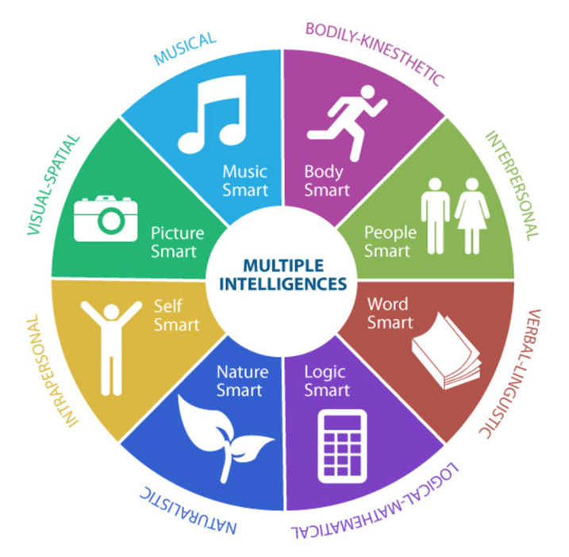
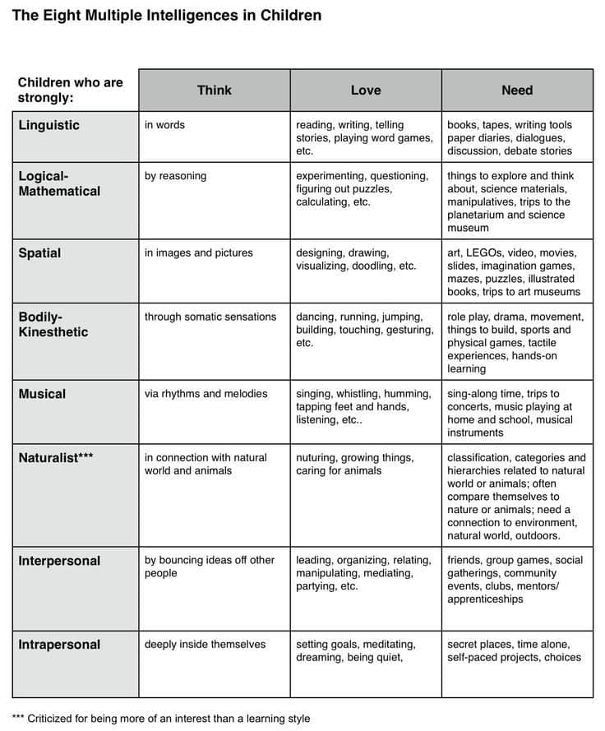

Howard Gardner’s Multiple Intelligences
Verbal-linguistic learners
• Have highly developed auditory (listening) skills
• Enjoy reading and writing
• Like to play word games
• Have a good memory for names, dates and places
• Are good at getting their point across

Logical-mathematical learners
• Like to explore patterns and relationships
• Enjoy doing activities in sequential order
• Are likely to enjoy mathematics and to experiment with things they don’t understand
• Find it challenging to solve problems and use logical reasoning

Visual-spatial learner
• Tend to feel at home with visual arts, maps, charts and diagrams
• Often think in images and pictures
• Can visualize clear images of things
• Often can complete jigsaw puzzles easily

Musical-rhythmic learners
• Are sensitive to the sounds in their environment
• Enjoy music and may prefer listening to music when they study or read
• Appreciate pitch and rhythm
• Probably like singing to themselves

Bodily-kinesthetic learners
• Process knowledge through bodily sensations
• Use the body in skilled ways
• Have good balance and coordination
• Are good with their hands
• Are able to manipulate objects with finesse
• Need opportunities to move and act things out
• Tend to respond best in classrooms that provide physical activities and hands-on learning

Intrapersonal learners
• Prefer their own inner world
• Like to be alone
• Are aware of their own strengths, weaknesses, and feelings
• Tend to think creatively and independently
• Like to reflect on ideas
• Often possess independence, self-confidence, determination, and high motivation
• Often prefer working independently rather than in groups
• May respond with strong opinions when controversial topics are discussed

Interpersonal learners
• Enjoy being around people
• Have many friends and engage in social activities
• Learn best by relating, sharing, and participating in cooperative group environments

