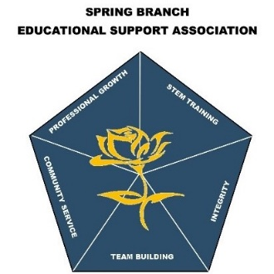 | SBESA  Spring Branch Educational Support Association  Affiliate of the Texas Educational Support Staff Association  955 Campbell Road • Houston, TX 77024  www.springbranchisd.com/about/sbesa

SBESA Scholarship Application

Applicant Information
SBISD Campus:

Student Name:
SBISD ID #: |  | Student Email
Address:
 | Street Address |  |  |  | Apartment/Unit #
 | City |  |  | State | ZIP Code

Phone: |  | Parent Email

Is your parent/guardian a Member of SBESA? | YES | NO | If so, how many years?

Applicant College, University, Trade School Information
Which college/university/trade school do you plan to attend?
Why did you select this particular school?
State briefly what field of study you are pursuing and why:
Have you received any other scholarships, grants, or forms of financial aid? |  | YES | NO | If so, how much?
Are you currently working 20 hours or more per week? |  | YES | NO | Do you plan on working during the 2021-2022 school year?
List organizations and/or extracurricular activities in which you have participated:

Certification and Signature
ALL APPLICANTS: I certify that all information I have provided on this form is true and complete to the best of my knowledge. I give permission to scholarship committee to review information on this form, my transcripts, and any additional supporting documentation submitted as part of this application. If chosen for scholarship award, I agree to provide proof of enrollment. I further agree if chosen to submit a photograph to be published.

Signature: |  | Date:

SBESA Scholarship Application

Applicant Information
SBISD ID #: |  | Student Email

Please enclose the following information:

A Letter of Recommendation:
Please provide one letter from a school official, teacher, or counselors.

A short essay, (350 words or less):
How do you intend to use your education

A copy of your current school transcript:
Official or Unofficial transcript from the Registrar’s Office or ask their counselor.

Current GPA

Thank you for applying for the SBESA Scholarship. All materials submitted to the committee are confidential. You must either type or print all your answers neatly in ink. Application response may be sent via email or inter office mail.

SUBMIT APPLICATION TO SBESA
SBESA - Attn: Silvia Urteaga
WAIS
901 Yorkchester Dr.
Houston, TX 77079
Or
Email: Silvia.Urteaga@springbranchisd.com

Scholarship application, transcripts, and letter(s) of recommendation must be submitted to the above address by
Tuesday, April 6, 2021 by 3 p.m.
LATE APPLICATIONS WILL NOT BE CONSIDERED

