CO
MARK YOUR NOVEMBER CALENDAR
1 - Advanced Movers Football Game SHS vs Jersey Village 7:00 PM at Tully
2 - Employee Wellness Kickball tournament @ SpringSpirit 9:00am
6 - P.A.P.A. Training at HISD Learning Center, 10725 Mesa Dr., Houston, TX 8:30-4:00. Click on link to register
7 - High School Student/Athlete Leadership trip to SHSU. Bus leaving NHS at 6:45 & SWHS at 7:00am
8 - 6 weeks grades due
8 - Advanced Movers Girls Basketball - MHS vs Brazoswood at MHS 4:00/5:30/7:00 PM
13 - Advanced Movers Swim Meet at Natatorium 6:00 PM
14 - SBHFTA Board Meeting 3:45 at WSC
15 - Advanced Movers Boys Basketball game SHS vs College Park at SHS 4:00, 5:30, 7:00pm
19 - Advanced Movers Girls Basketball MHS vs Fulshear at MHS 4:00/5:30/7:00 pm
19 - Advanced Movers Boys Basketball NHS vs Tomball Memorial at NHS 4:00/5:30/7:00 pm
20 - SBMSA Coaches meeting at Athletic office 5:30 PM
21 - SBHFTA Meeting at WCE 3:45 PM
25- Start of Thanksgiving break
29- Advanced Movers Volleyball SWHS vs Jersey Village 4:30/5:30 at SWHS
31-Advanced Movers Football game SWHS vs Cy Falls 7:00 Tully

HEALTH FITNESS
NEWSLETTER

November 2019

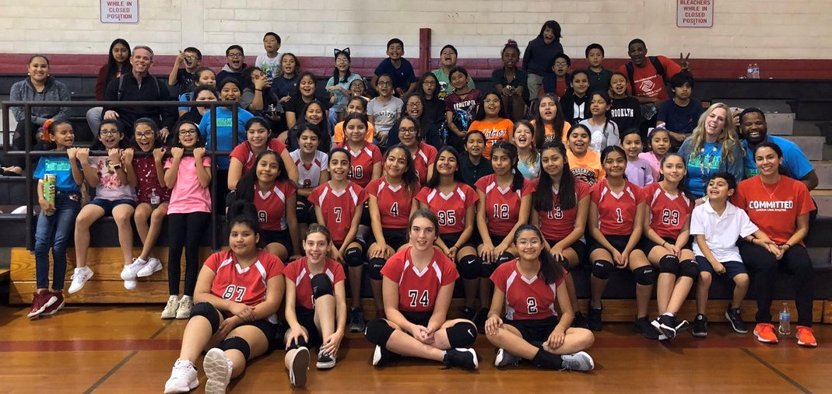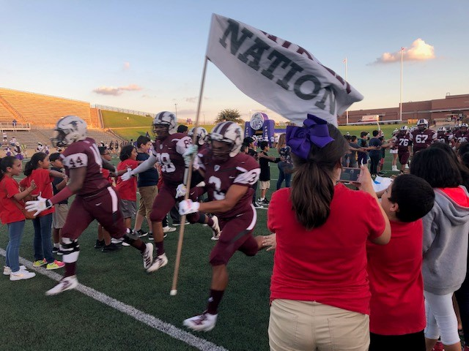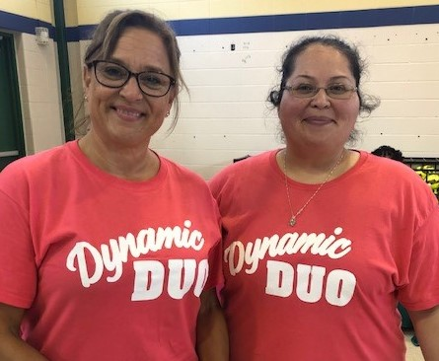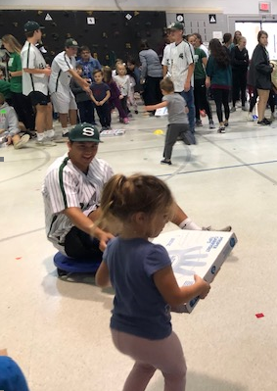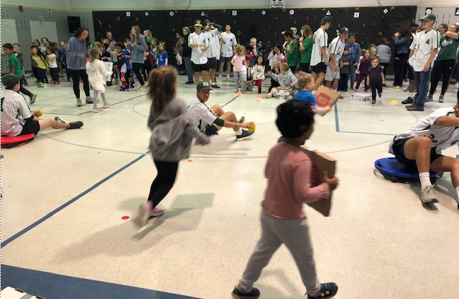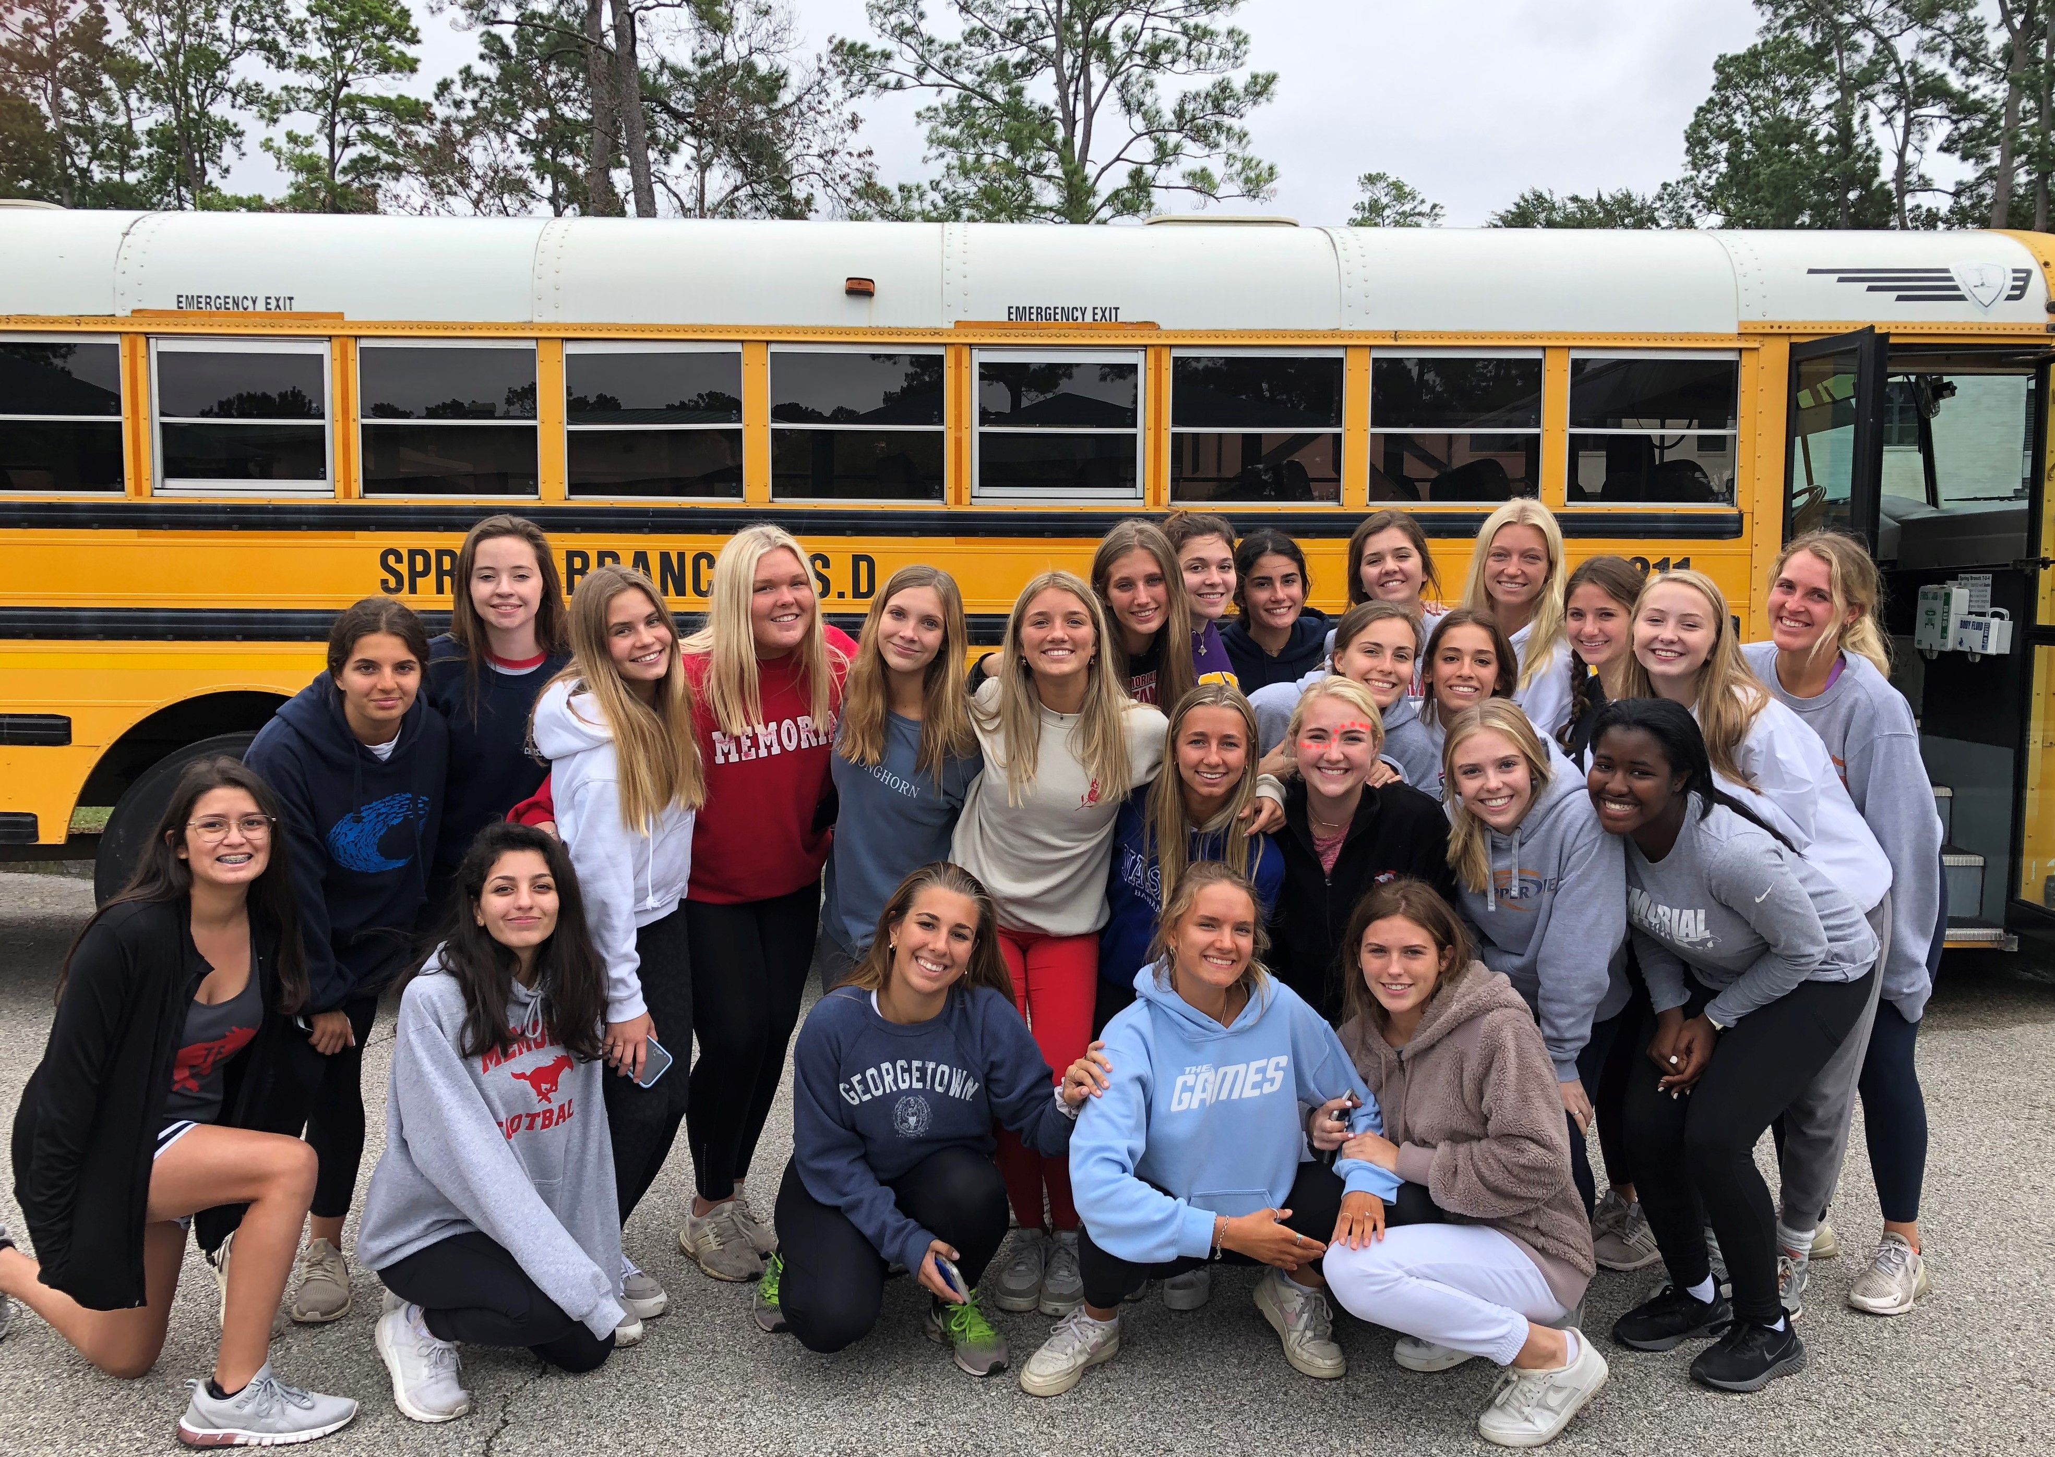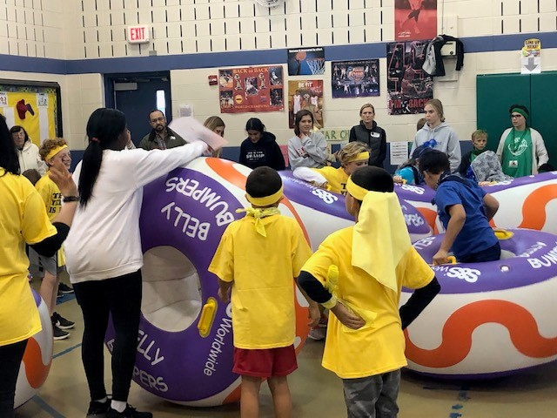

Your text hereTTh
Thanks to all of you who work so hard to give every child in SBISD such wonderful learning and serving opportunities. Your collective greatness is powerful. #loveourfeederpatterns

Equipment orders are due Jan 31st – please disregard the email that was sent with the Nov 1st deadline, but you also may order now.

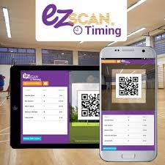
Have you tried your EZ Scan? Many of our schools already use the program and love it! Northbrook High School got started last week and are excited to use the data to track student success. The students at Meadow Wood love to compare their data on the pie chart to see which grade level and class are in the lead. Do you need help getting it started on your campus? Let us know and we will get it for you.

FitnessGram – the state has yet to purchase licensing for the current school year, so please be patient. We may not be able to input our results by December 13th, so keep your recorded results somewhere safe. I will let you know when it will be available online.

High School Coaches: If you cannot attend the P.A.P.A. training November 6th, I have attached the link for other upcoming trainings. https://csapps.oag.texas.gov/trainingcalendar
I have contacted the director in CyFair to see who the contact person is for the Berry Center one.

High School Student Leadership trip is scheduled for November 7th at SHSU. The bus will depart NHS at 6:45 am and SWHS at 7:00am. Breakfast, snacks, and lunch will be provided. Please email student waiver forms to Leslie Wylie.

SBHFTA NEWS:
Don’t miss the November 21st Association meeting at Wilchester Elementary. Anne Daily will be talking about Lawrenz Health Fitness Extravaganza.

Sign up for TAHPERD’s Annual Convention now at https://www.tahperd.org/web/Online/Events/Annual_Convention/Online/Events/Annual_Conference.aspx?hkey=074d7eb2-d4b7-4fbf-aae7-0f49c0120259 .

Remember our District Wide Health Fitness Focal Points while planning your lessons!
MHS Feeder pattern- locomotor skills, core, hand/eye coordination
NHS feeder pattern – locomotor skills, core, strength, technique/form
SHS feeder pattern – jumping, core, mobility/flexibility
SWHS feeder pattern – agility, core/balance, throwing

