Getting to Know You Survey (FALL)

Student Name:
School:
Date:

I like to read.

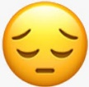

A lot! Yes Sometimes No

When I am at home, I read for fun.

A lot! Yes Sometimes No

I am a good reader.

Absolutely! Yes Sometimes No

How does reading make you feel?

Excited Happy Just ok Frustrated

